LEGISLATIVE INTENT SERVICE, INC.
712 Main Street, Suite 200, Woodland, CA 95695
(800) 666-1917 • Fax (530) 668-5866 • www.legintent.com

DECLARATION OF JENNY S. LILLGE

I, Jenny S. Lillge, declare:

I am an attorney licensed to practice in California, State Bar No. 265046, and am employed by Legislative Intent Service, Inc., a company specializing in researching the history and intent of legislation.

Under my direction and the direction of other attorneys on staff, the research staff of Legislative Intent Service, Inc. undertook to locate and obtain all documents relevant to the amendment of sections 1051 et seq. of Title 15 of the United States Code by United States House of Representatives Bill No. 9023 of
1920 [hereinafter referred to as H.R. 9023]. H.R. 9023 was enacted by Congress as Public Law 66-163, on March 19, 1920, at 41 United States Statutes 533.

The following list identifies all documents obtained by the staff of Legislative Intent Service, Inc. on H.R. 9023 of 1920 as it relates to Title 15 United States Code sections 1051 et seq. All listed documents have been forwarded with this Declaration except as otherwise noted in this Declaration. All documents gathered by Legislative Intent Service, Inc. and all copies forwarded with this Declaration are true and correct copies of the originals located by Legislative Intent Service, Inc.*

EXHIBIT A - PUBLIC LAW 66-163, H.R. 9023 (NOLAN – 1920):

- Public Law 66-163, March 19, 1920, 41 United States Statutes 533;
- Excerpts regarding Public Law 66-163 from the 1920
Catalogue of the Public Documents, from the 66th Congress;
- All available versions of H.R. 9023 (Nolan-1920) – Bill versions currently unavailable;
- Excerpt regarding Public Law 66-163 from the Calendars and History of Legislation of the House of Representatives 66th Congress, March 4, 1921;

* At this time, due to the public health emergency with regard to the novel coronavirus (COVID-19), our ability to provide some files and documents has been delayed. We will follow up with
additional files and other documents, if any, as soon as we gain access to them.

- Excerpt regarding H.R. 9023 from the Congressional Record Index, 66th Congress as follows:
  - First Session, Vol. 58, Part 9,
  - Second Session, Vol. 59, Part 9;
- Excerpt regarding H.R. 9023 from the Congressional Record of Proceedings and Debates, 66th Congress as follows:
  - House Debate, First Session, September 4, 1919, Vol. 58, Part 5,
  - House Debate, First Session, October 24, 1919, Vol. 58, Part 7,
  - House Debate, Second Session, January 21, 1920, Vol. 59, Part 2,
  - Senate Debate, Second Session, January 22, 1920, Vol. 59, Part 2,
  - Senate Debate, Second Session, February 21, 1920, Vol. 59, Part 4,
  - House Debate, Second Session, February 23, 1920, Vol. 59, Part 4,
  - Senate Debate, Second Session, February 26, 1920, Vol. 59, Part 4,
  - House Debate, Second Session, February 26, 1920, Vol. 59, Part 4,
  - House Debate, Second Session, March 10, 1920, Vol. 59. Part 4,
  - Senate Debate, Second Session, March 11, 1920, Vol. 59, Part 4,
  - House Debate, Second Session, March 12, 1920, Vol. 59, Part 4,
L. House Debate, Second Session, March 13, 1920, Vol. 59, Part 4,
- House Debate, Second Session, March 15, 1920, Vol. 59, Part 5,
- Senate Debate, Second Session, March 16, 1920, Vol. 59, Part 5,
- House Debate, Second Session, March 17, 1920, Vol. 59, Part 5,
- House Debate, Second Session, March 22, 1920, Vol. 59, Part 5;
- House Report No. 66-411, entitled “Convention for the Protection of Trade-Marks,” prepared by the House Committee on Patents, to accompany H.R. 9023, dated October 24, 1919;
- Senate Report No. 66-432, entitled “Trade-Mark Convention at Buenos Aires,” prepared by the Senate Committee on Patents, to accompany H.R. 9023, dated February 21, 1920;
- House Conference Report No. 66-739 entitled “Protection of Trade-Marks, Etc., Buenos Aires,” prepared by the Committee of Conference, to accompany H.R. 9023, dated March 12, 1920;

- Hearings held before the House Committee on Patents on
H.R. 9023 entitled “Protection of Trade-Marks,” dated October 15, 1919;
- Hearings held before the House Committee on Patents on
H.R. 9023 entitled “Protection of Trade-Marks,” dated February 25, 1920;
- Excerpt regarding Public Law 66-163 from The Trade-Mark Reporter, published by the United States Trade-Mark Association, Vol. 10, 1921;
- Excerpt regarding H.R. 9023 from The Official Gazette of the United States Patent Office, Vol. 339, No. 4, October 27, 1925;
- Excerpt regarding Senator or Representative John Nolan from the Biographical Directory of the United States Congress, available online at: http://bioguide.congress.gov.

EXHIBIT B – 66TH CONGRESS COMPETITOR BILLS, FIRST/SECOND SESSION RELATED TO H.R. 9023 of 1920:

- All available versions of H.R. 266 (Sims-1919) – Bill versions currently unavailable;
- Excerpt regarding H.R. 266 from the Congressional Record Index, 66th Congress First Session, Vol. 58, Part 9;
- Excerpt regarding H.R. 266 from the Congressional Record of Proceedings and Debates, 66th Congress, House Debate, Vol. 58, Part 1, May 19, 1919;
- All available versions of S. 580 (Fletcher-1919) – Bill versions currently unavailable;
- Excerpt regarding S. 580 from the Congressional Record Index, 66th Congress, First Session, Vol. 58, Part 9;
- Excerpt regarding S. 580 from the Congressional Record of Proceedings and Debates, 66th Congress, First Session, Senate Debate, Vol. 58, Part 9, May 23, 1919;
- Excerpt regarding S. 580 from the Patent and Trade Mark Review, Vol. 17, December 1918;
- All available versions of H.R. 7157 (1920) – Bill versions are currently unavailable;
- Excerpt regarding H.R. 7157 from the Calendars and History of Legislation of the House of Representatives, 66th Congress, 1920;
- Excerpt regarding H.R. 7157 from the Congressional Record Index, 66th Congress as follows:
  - First Session, Vol. 58, Part 9,
  - Second Session, Vol. 59, Part 9;

- Excerpt regarding H.R. 7157 from the Congressional Record of Proceedings and Debates, 66th Congress as follows:
  - House Debate, First Session, July 10, 1919, Vol. 58, Part 3,
  - House Debate, First Session, February 6, 1920, Vol. 59, Part 3,
- House Report No. 601 entitled “To Amend Section 5 of the Trade-Mark Act of February 20, 1905,” prepared by the House Committee on Patents, to accompany H.R. 7157, 66th Congress, Second Session, February 6, 1920;
- Hearings held before the House Committee on Patents on
H.R. 7157 entitled “Amendment of Trade-Mark Act,” dated January 21 and 22, 1920.

EXHIBIT C – 65TH CONGRESS PREDECESSOR BILLS, FIRST/SECOND SESSION RELATED TO H.R. 9023 of 1920:

- All available versions of S. 4783 (Fletcher-1918) – Bill versions currently unavailable;
- Excerpts regarding S. 4783 from the 1920 Index to Monthly Catalogue, United States Public Documents;
- Excerpt regarding S. 4783 from the Congressional Record Index, 65th Congress, Second Session, Vol. 56, Part 12, 1918;
- Excerpt regarding S. 4783 from the Congressional Record of Proceedings and Debates, 65th Congress, Second Session as follows:
  - Senate Debate, July 1, 1918, Vol. 56,
  - Senate Debate, August 29, 1918, Vol. 58;
- Hearings before the Senate Committee on Commerce on
S. 4783 entitled “Protection of Trade-Marks,” July 3 and 5, 1918;
- All available versions of S. 4889 (Underwood-1919) – Bill versions currently unavailable;
- Excerpts regarding S. 4889 from the 1920 Index to Monthly Catalogue United States Public Documents;
- Excerpt regarding S. 4889 from the Calendars of the House of Representatives, 65th Congress, Third Session, March 4, 1919;
- Excerpt regarding S. 4889 from the Congressional Record Index, 65th Congress as follows:
  - Second Session, Vol. 56, Part 12, 1918,
  - Third Session, Vol. 57, Part 5, 1919;
- Excerpt regarding S. 4889 from the Congressional Record of Proceedings and Debates, 65th Congress as follows:
  - Senate Debate, Second Session, August 29, 1918, Vol. 56,
  - House Debate, Second Session, September 12, 1918, Vol. 58,

  - 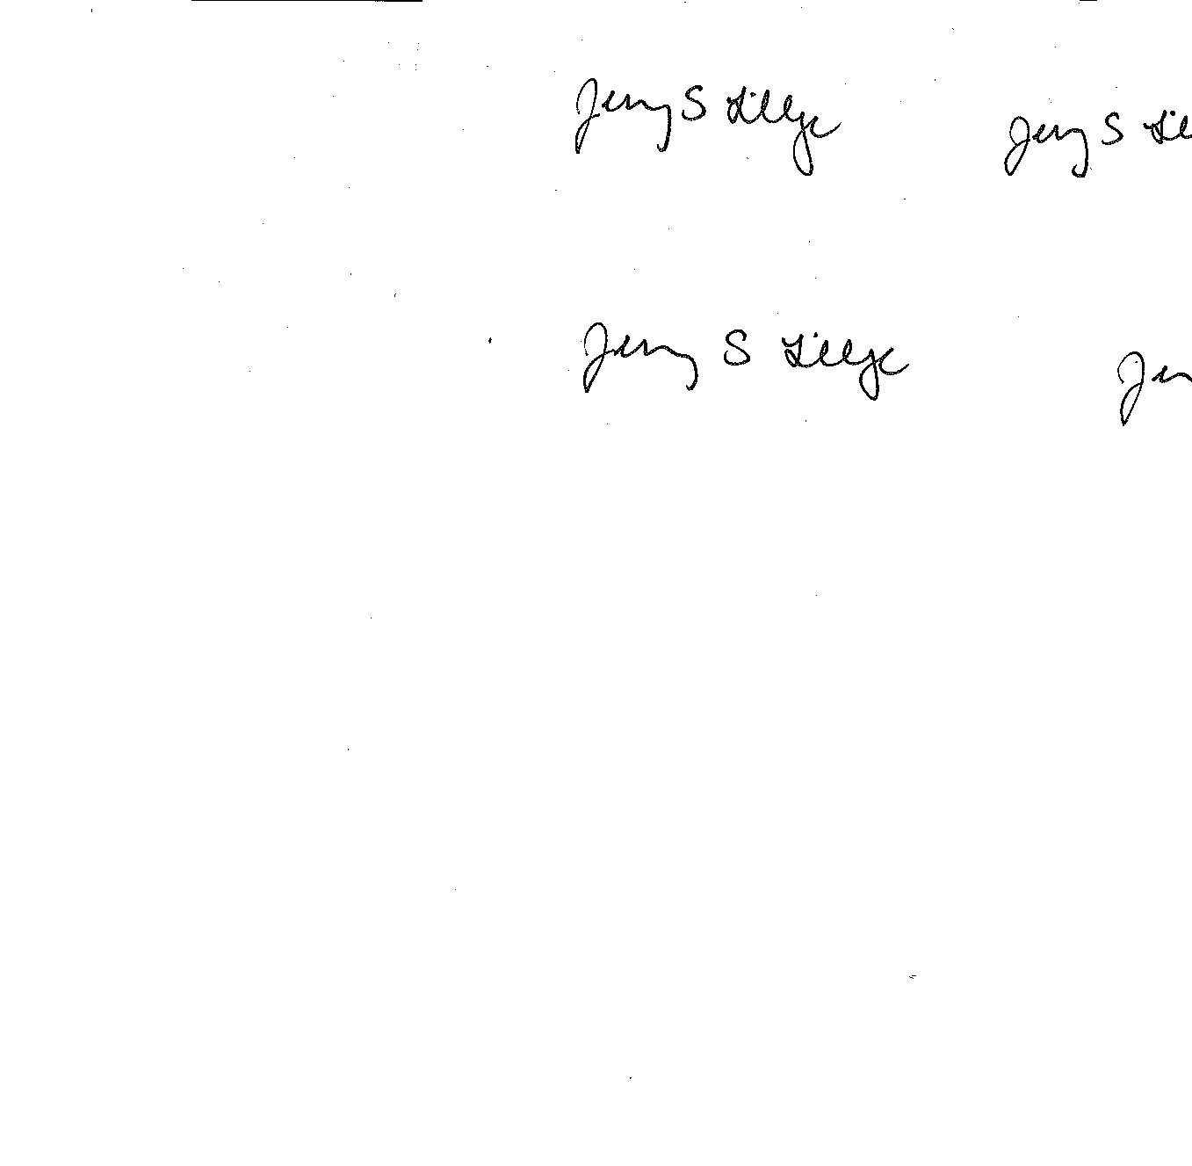House Debate, Third Session, February 18, 1919, Vol. 57;
17. Excerpt regarding trademark legislation from the Bulletin
published by the United States Trade-Mark Association, Vol. 14, 1919.

I declare under penalty of perjury under the laws of the State of California that the foregoing is true and correct. Executed this 8th day of January, 2021 at Woodland, California.

_______________________________ JENNY S. LILLGE

W:\Worldox\WDOCS\FEDBILL\ushr\9023\00239480.DOC

Page 5 of 5
- House Report No. 1090 entitled “Convention for the Protection of Trade-Marks,” prepared by the House Committee on Patents, to accompany S. 4889, dated February 18, 1919;
- Excerpt regarding S. 4889 from Patent and Trade Mark Review, Vol. 17, December 1918;
- All available versions of H.R. 12632 (Sims-1919) – Bill versions currently unavailable;
- Excerpt regarding H.R. 12632 from the Congressional Record Index, 65th Congress, Second Session, Vol. 56, Part 12, 1918;
- Excerpt regarding H.R. 12632 from the Congressional Record of Proceedings and Debates, 65th Congress, Second Session, House Debate, July 1, 1918, Vol. 56;
- Excerpt regarding Trademarks from the Business Digest, published weekly by the Cumulative Digest Corporation, August 14, 1918;

